Liability Action Process: Round 1 (Notice of Liability)
User Guide

TABLE OF CONTENTS

Page 2 CHECKLIST: All Rounds
Page 3 CHECKLIST: Round 1 (Notice of Liability) Page 6 INSTRUCTIONS: Round 1 (Notice of Liability) Page 6 ……..1. Overview
Page 7 ……..2. Document Preparation
Page 8 ……..3. Creating Your ‘Exhibit’
Page 9 ……..4. Preparing Your Bills of Lading (“BOLs”) & Printing
Page 10 ……..5. Preparing Your Envelopes
Page 11 ……..6. Signing & Copying
Page 12 ……..7. Mailing
Page 13 ……..8. Filing & Tracking

NOTICE
This material is not to be considered legal advice. The contents of this website, including but not limited to posted documents, videos and guides, comprise a lawful process based in commerce, and should be treated as such.

This is released in the spirit of service for the highest good, and is not intended to be utilized with the intention of malice, greed, or ill will of any kind.

Thank you for being the change we all want to see.

CHECKLIST: All Rounds

(Round 1) NOTICE OF LIABILITY REGARDING THE INSTALLATION OF TRESPASSING TECHNOLOGY (NOL)

Date shipped via Canada Post:
Next Round unlocks on 15th day from ship date:

(Round 2) NOTICE OF FAULT AND OPPORTUNITY TO CURE LIABILITY REGARDING TRESPASSING TECHNOLOGY and 2 AFFIDAVITS OF NON RESPONSE (NOF)

Date shipped via Canada Post:
Next Round unlocks on 15th day from ship date:

(Round 3) NOTICE OF DEFAULT AND IMMINENT LIABILITY REGARDING TRESPASSING TECHNOLOGY and
2 AFFIDAVITS OF NON RESPONSE (NOD)

Date shipped via Canada Post:
Next Round unlocks on 31st day from ship date:

(Round 4) 1ST ACCOUNTING and TRUE BILL (1 TB)

Date shipped via Canada Post:
Next Round unlocks on 31st day from ship date:

(Round 5) 2ND ACCOUNTING and TRUE BILL (2 TB)

Date shipped via Canada Post:
Next Round unlocks on 31st day from ship date:

(Round 6) 3rd ACCOUNTING and TRUE BILL (3 TB)

Date shipped via Canada Post:
Next Round unlocks on 31st day from ship date:

(Round 7) FIRST NOTICE TO DEBTOR (1 NTD)

Date shipped via Canada Post:
Next Round unlocks on 31st day from ship date:

(Round 8) SECOND NOTICE TO DEBTOR (2 NTD)

Date shipped via Canada Post:
Next Round unlocks on 31st day from ship date:

(Round 9) THIRD NOTICE TO DEBTOR (3 NTD)

Date shipped via Canada Post:
Enforcement unlocks on 31st day from ship date:

CHECKLIST: Round 1 (Notice of Liability)

CLAIMANT is you

USE THE SAME NAME ON YOUR DRIVERS LICENSE or I.D., BUT DO NOT TYPE IT UPPERCASE

NAME:

STREET ADDRESS (meter location):

CITY (meter location): PROVINCE (meter location):

MAILING ADDRESS: c/o

CITY (mailing): PROVINCE (mailing):
PREFIX YOUR MAILING ADDRESS WITH c/o WHICH MEANS “CARE OF” POSTAL CODE IS NOT NECESSARY FOR YOU OR YOUR WITNESSES

4 RESPONDENTS are the men or women you are holding liable. (No limit)

Respondent #1 (recommendation: electric utility CEO)

NAME: ORGANIZATION:

TITLE: GENDER:

THE PROCESS INCLUDES USE OF THE WORDS “man” OR “woman”

ADDRESS (mailing):

CITY: PROVINCE: POSTAL CODE:

Respondent #2 (recommendation: a state/province utility commissioner)

NAME: ORGANIZATION:

TITLE: GENDER:

ADDRESS (mailing):

CITY: PROVINCE: POSTAL CODE:

Respondent #3 (recommendation: a state/provincial legislator)

NAME: ORGANIZATION:

TITLE: GENDER:

ADDRESS (mailing):

CITY: PROVINCE: POSTAL CODE:

Respondent #4 (recommendation: a state/provincial legislator, local representative, or federal representative)

NAME: ORGANIZATION:

TITLE: GENDER:

ADDRESS (mailing):

CITY: PROVINCE: POSTAL CODE:

2 WITNESSES are the men or women who witness and sign the original documents in your process. Please keep the same witnesses throughout if possible, but not necessary.

USE THE SAME NAME ON YOUR DRIVERS LICENSE or I.D., BUT DO NOT TYPE IT UPPERCASE
PREFIX WITNESS MAILING ADDRESS WITH c/o WHICH MEANS “CARE OF” POSTAL CODE IS NOT NECESSARY FOR WITNESSES (OR FOR YOU)

WITNESS #1 NAME:

MAILING ADDRESS:

ADDITIONAL PRIVATE CONTACT INFO, SO IT’S HANDY:

PHONE:

CITY: PROVINCE:
EMAIL:

WITNESS #2 NAME:

MAILING ADDRESS:

ADDITIONAL PRIVATE CONTACT INFO, SO IT’S HANDY:

PHONE:

CITY: PROVINCE:
EMAIL:

FOR MAILING: USE CANADA POST (AS IT IS AN ADMINISTRATIVE AGENCY)

• 4 postal envelopes size 9x12”: 1 for each Respondent

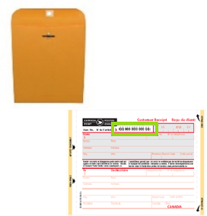
• 4 Registered Mail Labels/Receipts: 1 for each Respondent

More info about how to use Registered Mail: https://www.canadapost.ca/web/en/kb/details.page?article=how_to_prepare_regis&cattype=kb&cat=sending&subca t=generalinformation

BILL OF LADING FOR EACH RESPONDENT (See Bill of Lading Instructions for Details)

BLUE PEN FOR SIGNING ALL DOCUMENTS

COPIES FOR EACH RESPONDENT, TO MAIL INDIVIDUALLY. Make 4 copies of your signed NOL (with Exhibit), 4 copies of your Affidavit, and 1 copy of each signed Bill of Lading. This will be necessary for each step of process.

AFTER MAILING COMPLETED:

DATE SHIPPED:

WRITE TRACKING NUMBERS, then VERIFY SUCCESSFUL DELIVERY (via www.CANADAPOST.ca)

Respondent #1:
name tracking # date received / note

Respondent #2:
name tracking # date received / note

Respondent #3:
name tracking # date received / note

Respondent #4:
name tracking # date received / note

PLACE ORIGINAL DOCUMENTS, TRACKING # RECEIPTS, MAILING PAYMENT RECEIPTS INTO A FILE FOLDER NAMED “LIABILITY ACTION” – IN A SAFE PLACE *NOTE: NEVER SEND ORIGINALS!

Liability Action Process

INSTRUCTIONS: Round 1 (Notice of Liability)

1. OVERVIEW

WHAT WE ARE DOING:
We are sending a NOTICE OF LIABILITY REGARDING THE INSTALLATION OF TRESPASSING TECHNOLOGY (hereinafter “NOL”), to 4 Respondents, or people we are holding liable and accountable.

Then, for the signing:
You’ll meet with 2 WITNESSES
IMPORTANT POINTS IN CHOOSING WITNESSES:

• Your 2 Witnesses can be family, friends, or any living soul of age and sound mind.

• While it is not required for you to use the same 2 Witnesses for each round, it is recommended.

• Witnesses should be people with whom you can easily meet, at any time, and support your intentions in the process.

• Witnesses must use an address where personal mail is received, and it must be the same address for each step of the process.

• The 2 Witnesses are designated RECIPIENTS for correspondence from Respondents pertaining to this matter.

• Both Witnesses will need to sign with you there in person, at the time of your signing

• If you use a Notary Public (in Canada, not using a Notary is the default option), the Notary CANNOT be one of your two Witnesses for your document signing.

ALWAYS use a pen with BLUE INK to sign your original documents. You will keep your originals, and mail the copies.

Then, final steps:
MAKE COPIES (black and white is fine)
MAIL via CANADA POST Registered Mail (with 2 Witnesses present)
FILE your original documents, mailing & payment receipts, and completed Checklists in a secure file folder labeled “Liability Action”

2. DOCUMENT PREPARATION

1. For your information, your NOL is comprised of:

a. Notice of Liability

b. Followed by your customized Exhibit(s), as the last page 13. Details will be in the section “3. Creating Your Exhibit”.

c. Then your 3-page Affidavit – the pertinent facts of the matter which you verify to be true

d. On top of each of 4 document packages will be a 1-page Bill of Lading – including the individual Respondent’s address information and mailing package contents. More about this later, in the section “4. Preparing Your Bills of Lading”.
4. READ through your NOL and Affidavit to understand your document, and that everything is correct and aligned with your understanding. If this is not the case, do not proceed.
5. Next, FILL IN your Template in blank spaces indicated, which have a yellow background. Be thorough and concise.
6. After you edit each highlighted item, remove the yellow background in the areas which you just edited.

7. Do not use all uppercase letters, as this casing generally refers to corporations.
Do not change the order of pages in your document.
We strongly recommend not to change any other parts of the document, other than what’s highlighted, unless there is something you do not agree with.
8. Double-check that you have filled in all the areas that need editing.

9. After you’ve finished customizing your documents, Save As a new .doc on your, in a new folder in your computer which you’ll name “Liability Action”.

EXHIBIT(s)

Definition of “Exhibit”:
n. 1) a document or object (including a photograph) introduced as evidence during a trial. These are subject to objections by opposing attorneys just like any evidence. 2) a copy of a paper attached to a pleading (any legal paper filed in a lawsuit), declaration, affidavit, or other document, which is referred to and incorporated into the main document.

As it is referred to in the NOL itself, it must be included.

In the case of your Notice of Liability (Round 1) of the process, your Exhibit is the evidence of a “contract offer”, or intention, to use Trespassing Technology. So this could be either:

a) a printed webpage or email
b) a scanned letter from whomever is demanding to use Trespassing Technology
c) any other correspondence showing an offer for you to accept Trespassing Technology
Your Exhibit is your evidence of communications and demands to employ Trespassing Technology.

Step-by-Step: Creating your “Exhibit”

1. If you don’t have a letter or other propagand, go to their website and print the page that mentions their Trespassing Technology. If need be, call them and ask for them to mail you information. Either PRINT it out, or make a COPY of the original, as the case may be.
2. LABEL your Exhibit at top of the first page as EXHIBIT A and include it as Page 13, immediately following the 12- page NOL. Your Exhibit may be more than 1 page if need be. You may either type or hand-write EXHIBIT A.

3. Add your Exhibit to your NOL - insert after Page 12.
4. Do not staple anything yet. Paperclips are better to use at this point, until the documents have been signed &
copied.
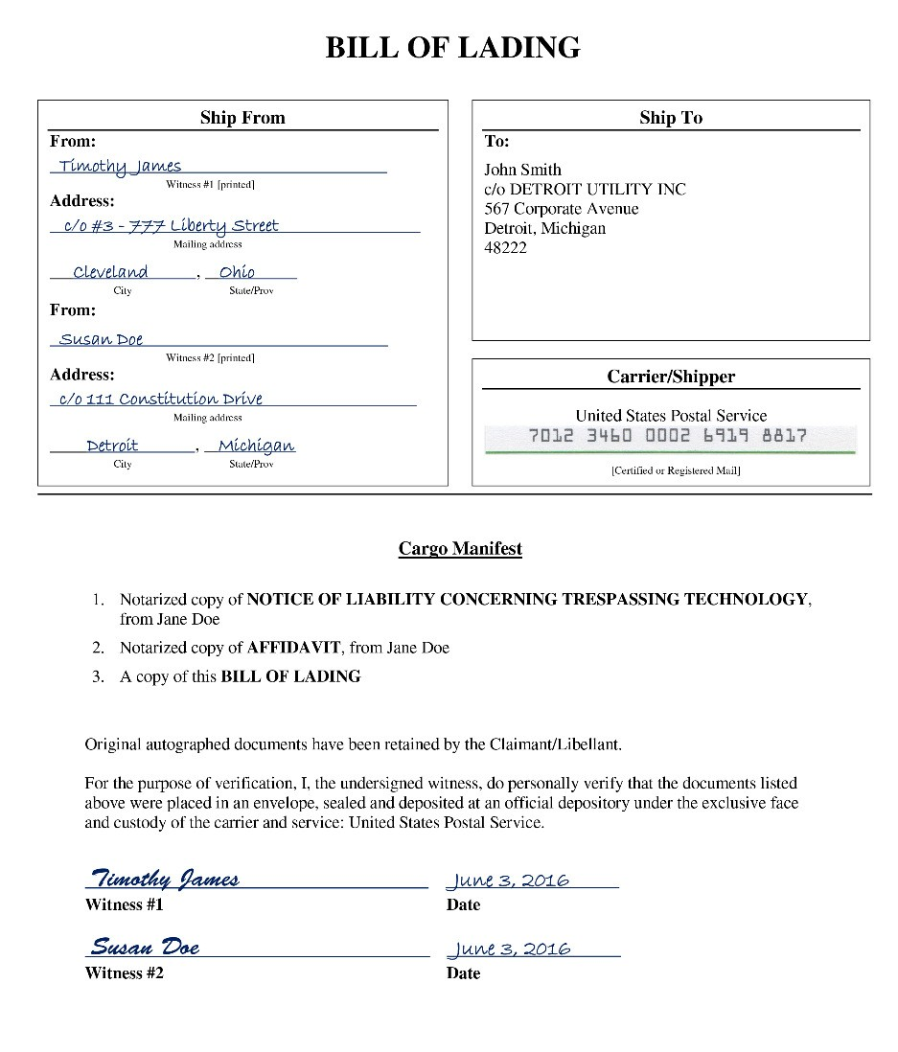
4. PREPARING YOUR BILLS OF LADING (“BOLs”) & PRINTING

BILL OF LADING (BOL)
Definition of “Bill of Lading”:
n. a receipt obtained by the shipper of goods from the carrier (trucking company, railroad, ship or air freighter) for shipment to a particular buyer. It is a contract protecting the shipper by guaranteeing payment and satisfies the carrier that the recipient has proof of the right to the goods. The bill of lading is then sent to the buyer by the shipper upon payment for the goods, and is thus proof that the recipient is entitled to the goods when received. Thus, if there is no bill of lading, there is no delivery.

A simple way to understand the Bill of Lading in this process is to think of the sending the NOL, or any Round in this process, as “shipping commercial cargo”. A Bill of Lading is for use within a commercial or administrative process, and you are shipping your cargo via the Post Office.

Step-by-Step: Preparing your BOLs & printing your documents
1. Open the NOL Template document you’ve been customizing. Locate the identical-looking Bill of Lading page, toward the end.
see the example at right.
2. CUSTOMIZE each of these in the YELLOW HIGHLIGHTED AREAS, and remove the yellow background.
3. Your Respondent information will be in the upper right. It is OK to use a postal code for your Respondents. But it is not recommended to use a postal code for yourself or your Witnesses, as it generally indicates a corporate or military jurisdiction.
4. If you are using a Notary, be sure add “Notarized copy of” prior to items #1 and 2, as seen in the example on the right.
5. The “Ship From” and the “Carrier Shipper” sections can remain blank for now, unless you know exactly who your 2 mailing Witnesses will be. These can be
different than your 2 signing Witnesses.
Though we recommend they stay the same.

6. Before printing your entire document,
double-check everything is accurate.

7. A NOTE REGARDING NOTARIES IN CANADA: Using a Notary is optional, and not included as the default option within Canada documents. Depending on your province, you may find it challenging to have a Notary sign your documents. In some areas such as British Columbia, Notaries have been subject to unlawful pressure to not participate in certain types of administrative commerce which challenge the status quo corporatocracy.
If you are going to use a Notary, bring your identification to the signing, and add the following Notary sections:
a) At the end of page 12 of your NOL (see the USA document templates for example of placement):

On this, the day of , 20 , before me, the undersigned notary public, appeared GivenName Surname, known to me (or satisfactorily proven) to be the one whose name is subscribed to the within instrument, and acknowledged execution of the same for the purposes therein contained.

In witness hereof, I hereunto set my hand and official seal.

b) And, at the end of page 3 of your Affidavit:
NOTARY PUBLIC

Sworn before me, the undersigned notary public, at the City of in the Province of

on this, the day of , 20 .

8. SAVE and PRINT your full 20-page, customized document.
NOTARY PUBLIC

5. PREPARING YOUR ENVELOPES

1. Pick up the following mailing supplies in before the mailing (before the signing) –

• 4 postal envelopes size 9x12”: 1 for each Respondent

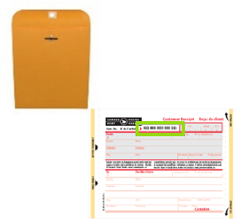
• 4 Registered Mail Labels/Receipts: 1 for each Respondent

More info about how to use Registered Mail: https://www.canadapost.ca/web/en/kb/details.page?article=how_to_prepare_regis&cattype=kb&cat=sending&subca t=generalinformation

2. FYI: When you purchase Canada Post Registered Mail, online (electronic) return receipts are included. This will be useful for your process, in which you will prove delivery.
3. Now, match up each Bill of Lading with a Registered Mail Label, and an envelope, and:
a. Put the thin “tracking #” sticker of the Registered Mail Label in the BOL’s “Carrier/Shipper” box, directly under “CANADA POST”.

b. Copying from the BOL, write the name & address for that Respondent, onto the main part of the Registered Mail Label. You will be keeping that portion of the Registered Mail Label for your records, but leave it on for now.
c. Remove the backing of the Registered Mail Label, and place the sticker on the envelope. Make sure to leave room on the middle portion to for the shipping address, and the top right portion of the envelope for postage.
i. Copying from the BOL, write the name & address for that Respondent, onto the envelope, just under where you placed the barcode sticker.
Leave the upper left (“from”) portion of the envelope blank for now.
NOTE: Postal codes are ok to use for Respondents, but we recommend not to use them for you or your
Witnesses’ mailing addresses.
d. IMPORTANT: Double-check that the names, addresses and tracking #’s on each Respondent’s Bill of
Lading, Registered Mail Receipt and Envelope all match each other.
4. Set aside your 4 unsealed envelopes, which will be filled after signing & copying.

6. SIGNING & COPYING

1. Make a signing appointment with 2 Witnesses (and a Notary Public if you choose to use one).

2. Meet your Witnesses and sign the documents in the presence of all parties.

3. At the signing, here’s what to sign:
a. You will date the top of the NOL (page 1); and then sign & date the NOL (page 12) and Affidavit (page 3). b. Witnesses will write their info in the NOL (page 11); and then sign & date the NOL (page 12) & Affidavit
(page 3).

IN CASE OF ERROR AFTER DOCUMENT HAS BEEN SIGNED BY CLAIMANT/LIBELLANT & WITNESSES
If any corrections need to be made prior to mailing, do a single strikethrough, write the correction, and initial.
Witnesses need not initial in this case.

CASE OF ERROR AFTER DOCUMENT HAS BEEN MAILED
If any corrections need to be made after mailing, you will need to send a NOTICE OF CORRECTION, which specifies any correction(s) which need to be made. This can be generally be included in the following round, or on its own.

4. Make photocopies of your signed NOL (w/ Exhibit) & Affidavit.
Later, at the time of mailing (at the post office), you’ll make 1 photocopy of each of your Bill of Lading pages.
You will send 1 complete copy set to each Respondent, then file your originals. NEVER SEND YOUR ORIGINALS!

7. MAILING

1. Prepare each COPIED document set for each of your 4 Respondents. For each of your 4 packaged envelopes, include in this order:
a. A copy of your Bill of Lading
b. A copy of your NOL which includes (12) page Notice of Liability c. A copy of your Exhibit (See Exhibit Instructions)
d. A copy of your Affidavit

2. As you prepare your documents, double-check that the names, addresses and tracking #’s all match up.

3. Staple all Respondent document packages, separately. We recommend to keep your originals paperclipped.

4. Package documents into labeled envelopes – one envelope per each Respondent – but do not seal yet!

5. Arrange with your 2 Witnesses to go to the Post Office (or a Shoppers Drug Mart with post office). It is necessary that the Witnesses be at the Post Office for the mailing. While we recommend to use the same Witnesses as you did for the signing, may be different if need be.

6. At the post office and prior to envelopes being closed up, your 2 Witnesses must complete the BOL and envelope, per the following:
i. Witness #1 prints his/her mailing addresses on the upper left of each envelope, as the main return address. We recommend not to use a Postal code for either you (Claimant) or the 2 Witnesses. If you do use a postal code, put square backets [ ] around it. We also recommend that a prefix of c/o is used, for either your or your Witnesses’ mailing addresses.
Sample Witness “From” Address: Witness’ Name
c/o Mailing Address
City, Province

ii. Witness #1 prints his/her name & mailing addresses in the “Ship From” section of each BOL. We recommend not to use a postal code here.
iii. Both Witnesses verify that the documents are included in each envelope, as listed on each BOL. Then both Witnesses read, sign and date the bottom of the BOL.
iv. If errors occur on the BOL, cross out error and write in correction and have the witnesses initial any errors – rather than you.
v. Still at the Post Office and with the envelopes still unsealed, make a copy of the Bill of Lading that was just signed AND INSERT THE COPY OF THE BOL - not the original - into the top of the mailing package. Most Post Offices / Shoppers Drug Marts have a photocopier. If yours doesn’t, you can first go to a nearby office store or (anywhere with copier) to copy the BOLs after they’re signed, then go to Post Office with your 2 Witnesses.
vi. Do one final check that the envelopes, addresses and tracking numbers all match up – for each of the 4 document packages. Make sure that each Bill of Lading matches its envelope address label and the Registered Mail Label tracking # -- and matches one of the names on the front of your NOL.
vii. With COPIES of all documents enclosed, seal the envelope and give to the post office clerk for payment and processing of receipts. Be sure to keep your payment receipt, and the stamped address portion of the 4 Registered Mail Labels.

8. FILING & TRACKING

1. When you get home, create a file for this process, and label it “Liability Action”. Store your original signed documents in it, along with your payment receipts and Registered Mail Labels/Receipts. Keep in a VERY SAFE PLACE. The Registered Mail Receipts are very important because they (along with your BOL originals) will have Tracking numbers – which will be necessary to prove shipping and receipt of your documents.

2. Kick back and celebrate your participation in standing up for life & co-creating actual change from the top- down... and from the bottom-up. So Be It.

3. IN 3-6 DAYS: Several days after mailing, log into www.CanadaPost.ca and look up your 4 tracking #’s, to verify that the packages were delivered.

a. IF THEY WERE ALL DELIVERED SUCCESSFULLY:
Print out the receipt PDFs with signatures, and store them with your originals in your Liability Action
folder.

b. IF ANY WERE NOT DELIVERED SUCCESSFULLY OR WERE REFUSED:
Working with our Seed Groups, on the rare occasion a package was not delivered or was refused – even though it was sent via Certified (in USA) or Registered Mail. This seemed to be indicative (in most of these cases) that the Respondent was aware of, and afraid of, the Liability Action – and trying to evade
it. If you experience this, we recommend you either send it via Registered Mail again, or have it “served” in person. You can do this yourself with witnesses, or you can hire a process server. Contact us for specific help if you are in this position.

4. IN 15+ DAYS: Do Round 2 of the process, the “Notice of Fault and Opportunity to Cure Liability”.
Minimum 14 full days from shipping date of Round 1.



------------------------------------------N.O.L. SECTION ENDS HERE---------------------------------------------

NOTES

